Debug support in STM32 Discovery

In STM32 Discovery evaluation board, debug support model is identical with general model used in Cortex-M4 family of processors. Its complex debug extension allows to examine both the state of the core and external system state, provided that the core is stopped. This architecture supports two different modes of debugging: serial wire debugging and JTAG debug port [MAN]. By default, JTAG debug port is the active mode – switching to serial wire debugging requires sending a special bit sequence on the TMS pin.

When JTAG debug port is chosen as active mode, two separate Test Access Ports can be distinguished: Boundary Scan TAP and Cortex-M4 TAP. Connection between both ports is shown in Fig. XX.

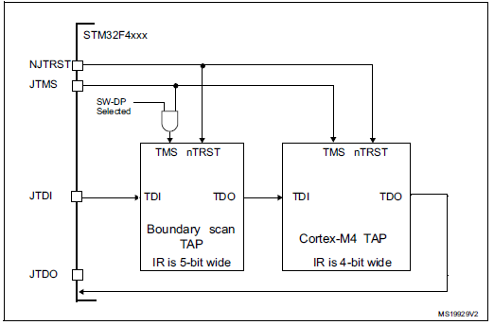
Fig. XX JTAG TAP connection in STM32. Source: [MAN]

Boundary scan TAP and Cortex-M4 TAP are daisy-chained, so that output of boundary scan TAP becomes input of Cortex-M4 TAP. Their instruction registers vary in length, what allows to bypass them separately. The connection between test access ports must be taken into account during testing: if one of the test access ports is set as bypass, it adds one extra bit to the output data. Reset (NJRST) and test mode select (JTMS pin) are common for both test access ports.

Several ID codes are present inside the MCU. All of them may be accessed by using the JTAG debug port. All the codes are listed in Tab. XX.

Tab. XX Codes used in JTAG debug port of STM32 Discovery. Source: [MAN].

Code name | Location | Code length [bits] | Value | Remarks
DBGMCU_IDCODE | STM32F4 MCU | 32 | 31:16 depends on revision  15:12 reserved  11:0 Device identifier:  0x413 for STM Discovery | Used to identify ST MCU part number and the die revision.
JTAG ID Code | Boundary Scan TAP | 32 | 0x06413041 | JTAG identification
Cortex-M4 JTAG ID Code | Cortex-M4  TAP | 32 | 0x4BA00477 | ARM-default code, accessible only by JTAG Debug Port

Cortex-M4 JTAG debug port instructions

Cortex-M4 JTAG debug port enables two aforementioned basic instructions: BYPASS and IDCODE. It is however enhanced with its following custom instructions:

- DPACC instruction – instruction initiating a debug port and allowing access to a debug port register. Bidirectional data transfer is possible – data can be written or read.
- APACC instruction – instruction initializing access port and allowing access to an access port register. Again, bidirectional data transfer is possible. Moreover, several additional operations may be requested, i.e. System or debug power-up or reading status flags.
- ABORT – instruction generating an abort when its least significant bit is set (all other bits of this instruction are reserved).

xPACC instructions: DPACC and APACC
Whole structure of the debugging registers is shown on Fig.XX /schemat z ARM Debug Interface/
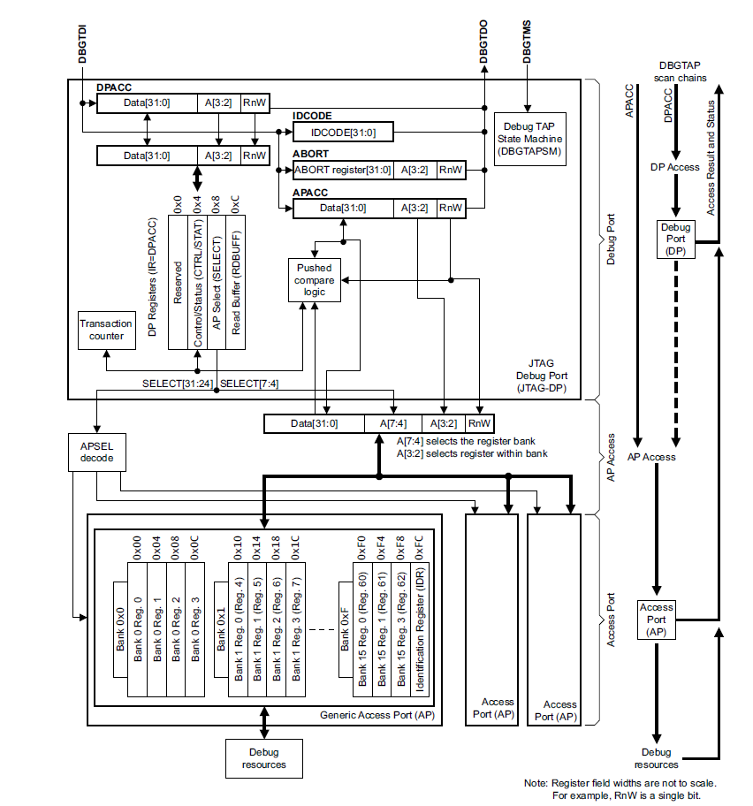
Fig.XX Structure of the Debug Access Port in DPv0 with shown structure of DPACC and APACC commands. Source: [ARM]
Both APACC and DPACC data registers are 35-bits wide. Bits are shifted to appropriate data registers on a rising edge of TCK, LSB first. When shifting data in, their least significant bit RnW[0] determines whether read or write instruction takes place, two next bits A[2:1] chose the command and the remaining 32 bits include data. When shifting data out, three least significant bits include the acknowledge command and the remaining bits include data. Acknowledge command indicates whether the operation finished or it is still in progress. Finishing the transaction does not mean that it has been successful. To see the result of an operation, one must read the status word of the access port.
APACC instructions review
APACC instruction is used to gain access to the AHB bus. AHB transactions use the optional AHP access port into Cortex-M4 system that allows them to access all memory and system registers, as described in [Cor]. As shown on Fig.XX, these registers are organised in banks and banks are organised in access points. Many various access points may be selected. However, the basic Cortex-M4 processor has only one access point, therefore AP select index must be always set to 0x00.
There are many APACC-specific registers widely described in [ARM], including:
- APACC control/status word;
- APACC configuration register;
- Transfer Address Register (TAR) holding the value for the incoming access to memory system. This address may be auto-incremented;
- Data Read/Write Register (DRW) used for memory read/write operations;
- Banked Data Registers that provide read or write access to block of four words of memory;
- Debug port ID code and identification register;
- Debug address base register.
Naturally, not all of these instruction (i.e. AP’s configuration registers) initiate a memory access.
DPACC instructions
The DPACC instruction allows to configure so-called debug point registers. There are 3 main debug registers:
- CTRL/STAT – status word register showing current state of the transmission, including transaction counter and sticky error bits;
- SELECT – register used to select registers accessed by the APACC instruction as well as currently used bank of the access point. As shown in example in [ARM, p.1-25], if one wants to read bank with address denoted as 0xAB, A value must be set in the SELECT register, whereas the B value is adjusted by appropriate values used in APACC commands. There are only four allowed values of B: 0xC, 0x8, 0x4 and 0x0 – its two least significant bits are always equal to zero.
- RDBUFF – read buffer of a former APACC transaction. It may be read once, since it is a simple shift register. Its second read gives unpredictable results.

References

[MAN] STM32F405xx/07xx, STM32F415xx/17xx, STM32F42xxx and
STM32F43xxx advanced ARM-based 32-bit MCUs.

[MAU]

[IEE] 1149.1 IEEE standard;

[ARM] – ARM v5 Debug Interface;
[Cor] – ARM Cortex M4 Processor Technical Reference Manual, r0p1.

